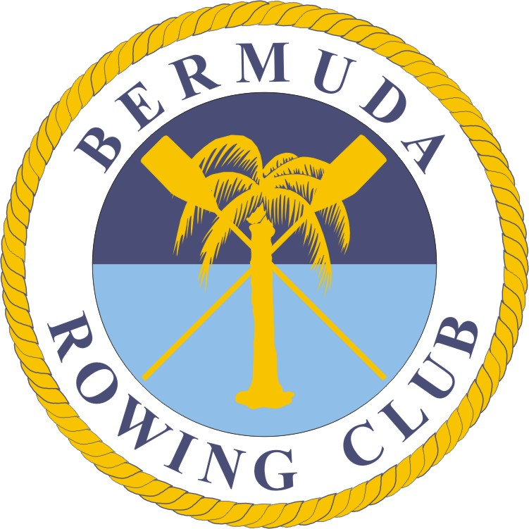
Bermuda Rowing Association
ADULT Application for 2025 Learn to Row Camp
Name: ______________________________________ D.O.B dd_____ /mm_____ /yy______
Mailing address : _____________________________________________________________________
Telephone: Home_________ _______ Work __________________ ____ Cell ______________________
Emergencies: Name _______________________________________ Tel 1_________ Tel 2________
Email: _______________________________________________________
Occupation or place of education __________________________________________________________
Previous rowing history___________________________________________________________________

Learn to Row Camp Dates and Camp Preference – Please circle *450/Camp
Camp 1 – June 1-11 | 6am - 8:15am Monday - Saturday
Camp 2 – July 14-25 | 6am - 8:15am Monday - Saturday
Payment accompanying this application $__________ (Payable to the Bermuda Rowing Association by mail
or by direct bank payment to Clarien Bank 6000237594 Ref [name of Participant].

YES/NO Can you swim a minimum of 150 meters in rowing kit?

YES/NO Do you have any medical condition(s) that might affect your ability to participate?
If YES, please specify ____________________________________________________________________

YES/NO Do you have Health Insurance?

YES/NO Can we sign you up to our Whatsapp account for rowing?

Note 1: You are responsible for your own health and judgment as to whether you are able to participate on health grounds. We strongly encourage you to seek a professional medical opinion if you are in any doubt. The Bermuda Rowing Association will not be held liable in any way for any injury or health problem as a result of participating in the sport.

Note 2: As the National Sports Governing Body for rowing we subscribe to the WADA code and we are all eligible for random drug testing. For further details see: http://www.olympics.bm/drugsinsport.htm

I hereby make an application to become a member of the Bermuda Rowing Association. I agree to conform to the Association’s Code of Conduct, Articles of Association, and any other rules which may be made by the Association from time to time. Copies of all of these may be found on the Association’s website at www.bermudarowing.com.
I understand that my personal details will be held on a computer for the sole use of the Bermuda Rowing Association.
Signed: ________________________________ Print Name: _________________________________
Date: __________________

