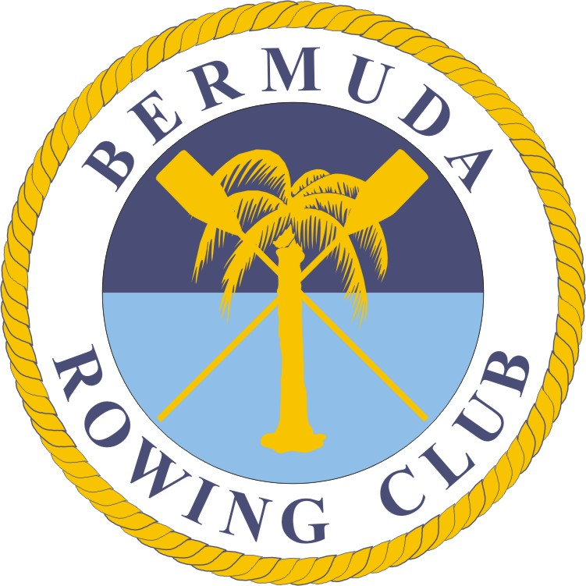
Bermuda Rowing Association
Application for JUNIORS Summer 2025 Rowing Camp
Name: __________________________________________________________ D.O.B dd___/mm___/yy_____
Mailing address : ________________________________________________________________________
Telephone: Home___________________________________________ Cell ____________________________
Emergency Contact Info: Name ____________________________Relationship __________________________
Tel 1________________________________ Tel 2__________________________________________________
Email: ________________________________________________________________________________
Place of education _________________ Previous rowing history______________________________________
Please tick- Camp1 - June 30 – 11, 9-12pm ______ $350 Camp2 - July 14 – Jul 25 ______ $350, 9-12pm
Payment accompanying this application $__________ (Payable to the Bermuda Rowing Association please, or by direct bank payment to Clarien Bank 6000237594 Ref [name of Participant].
Can you swim a minimum of 150 metres in rowing kit? YES / NO
Do you have any medical condition(s) that might affect your ability to participate? YES / NO
If YES, please specify ________________________________________________________________________
To be completed Guardian if the applicant is under 18 years:
Note 1: You are responsible for your own health and judgment as to whether you are able to participate on health grounds. We strongly encourage you to seek a professional medical opinion if you are in any doubt. The Bermuda Rowing Association will not be held liable in any way for any injury or health problem as a result of participating in the sport.
I agree to conform to the Association’s Code of Conduct, Articles of Association, and any other rules which may be made by the Association from time to time.
I understand that my personal details will be held on computer for the sole use of the Bermuda Rowing Association.
Signed: ________________________________ ____________________________ Date: __________________

Signature of Parent or Legal Guardian _____________________________________Date: __________________
PLEASE EMAIL THIS APPLICATION TO BermudaRowingAssociation@gmail.com

